Lab 4
Date Assigned: 9/28/2015
Lab Report Due: Midnight 10/05/2015 on iLearn

- You may want to bring your textbook to labs to look up syntax and examples.
- Have a question? Ask your instructor for help, or look at the book or past lecture slides.
- We encourage you to talk to your classmates; it's okay to discuss ideas (but NOT copy code) during lab.
- You probably won't finish all of the exercises. Do as much as you can in the allotted time. You NEED to finish the rest after you leave the lab.
- Before you leave, SHOW your work to your instructor to get credit for your work in lab.
- Complete all sections and turn in a report to iLearn before the deadline. See turn-in check list (at the end of this document) for more details.
- For each lab, lab attendance and your work during lab 40%, lab report 60%.

Section 1: CSS and DIV
<!DOCTYPE html>
<!-- My First Webpage -->
<!-- Author: Bowu Zhang -->
<!-- CMPT 120 Lab 4, August 31, 2015 -->
<html>
<head>
<meta charset="utf-8" >
<title>More about CSS</title>
</head>
<body>
<h1>This is heading 1. We define the style of tag h1 in style.css. For example, we can specify the text color, font size, font family, and background color. </h1>
<h2>This is heading 2. We can specify multiple properties in CSS file for one tag at a time. </h2>
<h2>This is heading 2. We can use division tag to group elements </h2>
<p>This is a paragraph. Try as many style properties in style.css as possible.</p>
<ul>
<li>Check</li>
<li>Out</li>
<li>This List</li>
</ul>
<img src="https://upload.wikimedia.org/wikipedia/en/8/8c/Marist_Red_Foxes_logo.png" alt="Marist College">
<!-- this is a comment and is totally ignored by the browser-->
</body>
</html>
- Create a folder lab4 on the desktop. Create a html document morecss.html that includes code in the above example, and save it in lab4. View the page in Chrome.
- Create an external stylesheet with the following style rules:
h1 {
text-align: center;
font-family: "Courier New";
color: red;
}
Save this file as morecss.css in your lab4 folder. Make sure your morecss.css file has an extension of .css, NOT .html.
- Then, at the top of the morecss.html file, in the head section of the document, connect this stylesheet:
<link href="morecss.css" rel="stylesheet" type="text/css">
Reload the morecss.html page in the browser.
- With your files all set up, you can start adding CSS rules to morecss.css, following the format of
selector {
property: value;
property: value;
/* you can add more properties */
}
- Add rules to morecss.css that color texts in h2, p, and ul green. Verify changes by reloading the morecss.html page in the browser. Show the instructor your work before you work on the next step.

The div tag (short for division) is a generic container tag. A div can contain anything (paragraphs, lists, headers, and even other divs), and is often used together with CSS to apply styles to a group of elements in a HTML page.

- Delete all the rules you made in step 5. Instead of making multiple rules, let’s group elements by using div tag, then what we need is just a single rule over the group in CSS.
  - Group h2, p, ul in morecss.html by adding an opening tag <div> in morecss.html before the opening tag of h2, and a closing tag </div> after the closing tag of ul.
  - In morecss.css, add the following CSS rule:
div {
color: green;
}
  - Verify changes by reloading the morecss.html page in the browser.

Section 2: CSS and ID, CLASS
<!DOCTYPE html>
<!-- Author: Bowu Zhang -->
<!-- CMPT 120 Lab 4, August 31, 2015 -->
<html>
<head>
<meta charset="utf-8" >
<title>CSS and ID, CLASS</title>
</head>
<body>
<p>This is the start of our example.</p>
<p> Our mission is to provide the most
spectacular spatulas and splurge on our specials until our
customers <q>esplode</q> with splendor!
</p>
<p>Spatula City! Spatula City!</p>
<p>See our spectacular spatula specials!</p>
<p>Today only: satisfaction guaranteed.</p>
<h2>Spatula City! Spatula City!</h2>
</body>
</html>
- Create a html document cssidclass.html that includes code in the above example, and save it in lab4. View the page in Chrome.
- Create an empty external stylesheet cssidclass.css in your lab4 folder. Make sure your cssidclass.css file has an extension of .css, NOT .html.
- Then, at the top of the cssidclass.html file, in the head section of the document, connect this stylesheet:
<link href="cssidclass.css" rel="stylesheet" type="text/css">

The id attribute (short for identifier, like a driver's license is a kind of ID card) is often used together with CSS to apply styles to elements in a HTML page. An id can be used as the selector in a CSS rule.
- To style texts in the following p element in cssidclass.html (though there are other p elements in cssidclass.html, here we only work on the p element below),
<p> Our mission is to provide the most
spectacular spatulas and splurge on our specials until our
customers <q>esplode</q> with splendor!
</p>
first, add an attribute id="mission" to the opening tag of p. Basically, you can assign id any value. If you want to label them “mission”, “critical” or “crit” or whatever, that's your choice. However, the value of id has to be unique. No two tags can have the same id.
Then add the following rule to cssidclass.css:
#mission {
font-style: italic;
font-family: "Garamond", "Century Gothic", serif;
}
Notice the syntax here: the id mission is preceded by a # symbol. The id selector picks out the element with that id mission, and only that element, to apply the style to.
- Reload the morecss.html page in the browser. You should be able to observe that only the paragraph with id="mission" is changed.
- Using id, add rules to cssidclass.css to style texts in the following p element in cssidclass.html, and only this p element:
<p>This is the start of our example.</p>
- make background-color orange.
- make text color blue.
You can assign id any value, but the value has to be unique. Reload the morecss.html page in the browser.

One drawback of using an id is that an id has to be unique, so you can only style one element using an id. Suppose we have various elements on our page that are important, and we want to style them differently from non-important elements. We could number them important1, important2, and so on, but that would be unbearably tedious. Instead, we want to describe a kind or category of element, which CSS calls a class of element.
- In cssidclass.html, add attribute class to the following elements:
<p class="shout">Spatula City! Spatula City!</p>
<p class="special">See our spectacular spatula specials!</p>
<p class="special">Today only: satisfaction guaranteed.</p>
<h2 class="shout">Spatula City! Spatula City!</h2>
You can see that class works just like id, in that you specify it as the value of an HTML attribute. Note that, just like id, you as the author of the web page get to decide what the id or class is. If you want to label them critical, or crit or whatever, that's your choice.
- Now let's turn to the CSS side of things. In cssidclass.css, add following rules to style elements above:
.special { /* any element with class="special" */
background-color: yellow;
font-weight: bold;
}
.shout { /* any elements with class="special" */
color: red;
font-family: cursive;
}
Note the syntax of the selector. The name of the class is preceded by a dot or a period. All the elements with that class get that style rule applied. Reload the morecss.html page in the browser.
- Add the following list to cssidclass.html:
<ul>
<li>milk<\li>
<li>bread<\li>
<li>apples<\li>
<li>bananas<\li>
<li>toilet paper<\li>
<li>soap<\li>
</ul>

- Using class, add rules to cssidclass.css to style the above list in cssidclass.html:
Make milk, bread, and toilet paper (only milk, bread, toilet paper) red.

Section 2: “About Me” Page
- In this section, we will continue to work on “About Me” page we created in lab 2. Copy and paste your aboutme.html in lab4.
- In lab4, create an empty stylesheet aboutme.css to improve the appearance of your About Me page. Then, at the top of the aboutme.html file, in the head section of the document, connect this stylesheet:
<link href="aboutme.css" rel="stylesheet" type="text/css">
- In aboutme.css, add style rules to
- Change the color of at least two elements
- Change the font properties (family, size, weight, or style) of at least two elements. Some standard fonts: Arial, Arial Black, Verdana, Trebuchet MS, Georgia, Tahoma, Courier New, Times New Roman
- Change at least one other thing (e.g. background color, text alignment, etc.)
- Validate aboutme.css in https://jigsaw.w3.org/css-validator/.
- Connect aboutme.css to aboutme.html. View the page in a web browser.
Example (Your page doesn’t need to be exactly the same):
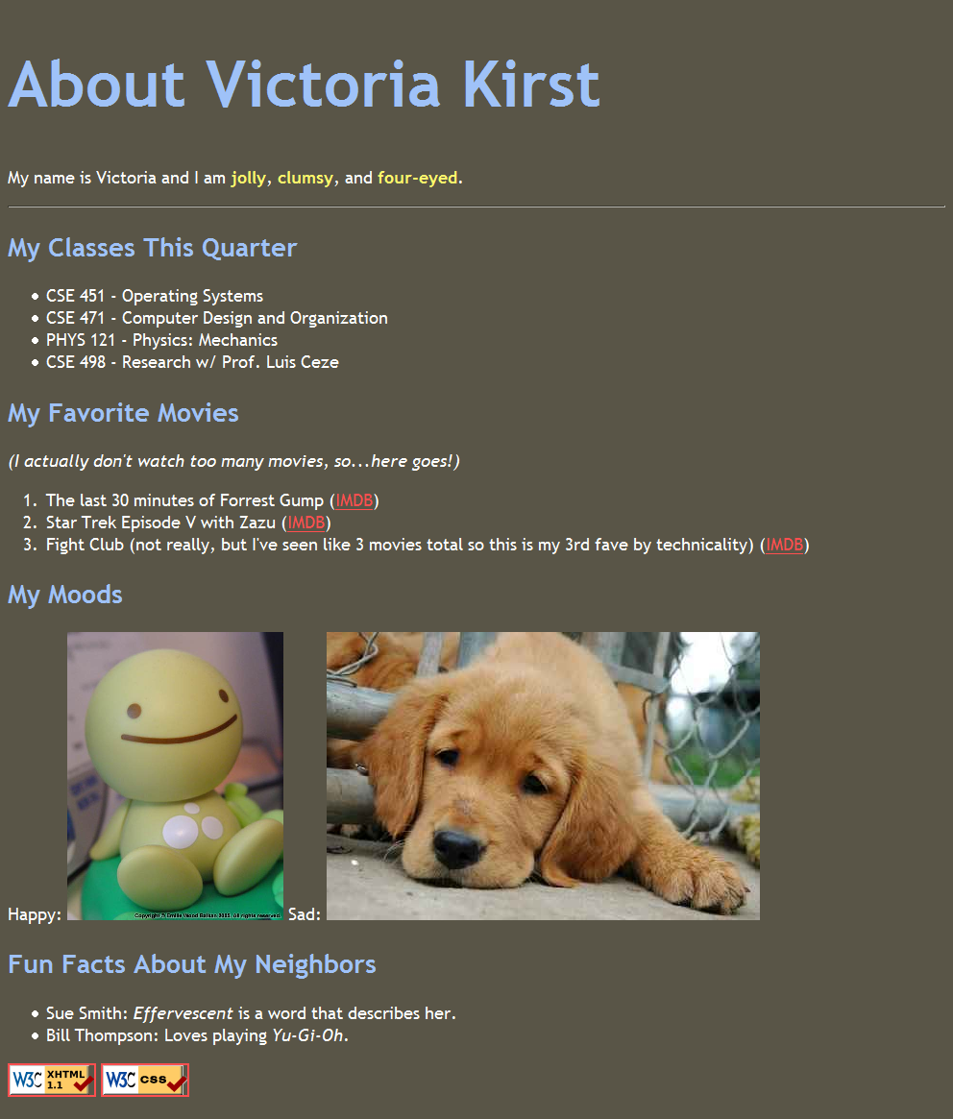

TURN-IN CHECKLIST:

- Source Code (.html/.css/.js files) created in this assignment. Remember to include your name, the date, and the lab number in comments near the beginning of your code.
- Create a folder and name it 'FirstName_LastName_lab_4'. In the newly created folder copy and paste your source code (.html/.css/.js files). Then compress the folder, and upload it to iLearn.

